Developing an Yb/Nd doped hybrid solid laser of RF gun for SuperKEKB phase II commissioning
X. Zhou†, T. Natsui, M. Yoshida, R. Zhang, Y. Ogawa, KEK/SOKENDAI, Tsukuba, Ibaraki 305-0801, Japan
Abstract
By development of the Yb-doped laser system, more than 1.0 nC electron with double-bunch has been obtained in 25 Hz. The Yb-doped laser system is already for commissioning for the linac. Next, a new Nd:YAG laser system is development to improve the stability and reliability.

Introduction
The electron beams with a charge of several nC and a normalized emittance of less than 10 μm are expected to be generated in the photocathode RF gun for injector linac of SuperKEKB accelerator project. By development of the Yb-doped laser system, more than 1.0 nC electron has been obtained in 25 Hz. The laser system is already for commissioning phase I. But, the 30 ps pulse width stretch limit the pulse energy of the amplifier laser system. And the nonlinear effect was occurred.
As well-established laser material, Nd:YAG rods with high optical homogeneity and high damage threshold, simplify the design of high pulse energy amplifier. Therefore, a new Yb-doped fiber and Nd:YAG hybrid laser system is development to increase the pulse energy and stability of the laser source. The emission wavelength of the Nd:YAG is narrowband around 1064 nm. Also, a new laser room was built to increase the stability of the temperature humidity condition. For phase II commissioning, more than 2 nC low emittance electron beam is expected. For laser source, ~20 ps, 500μm Ultraviolet (UV) pulse source is required.
Also, a chirped pulse amplification (CPA) Yb-doped fiber and Yb;YAG thin-disk laser system is prepared for the phase III commissioning, both pulse energy and pulse shaping controller are expected. The emission wavelength of the Yb:YAG is broadband around 1030 nm.

Laser system
As the fig. 1, the laser system starts with Yb-doped fiber oscillator. The 1064 nm seed pulses was generated with an all normal dispersion (ANDi) structure fiber cavity. The 1030 nm seed pulses was generated with a commercial fiber oscillator (Menlo Systems GmbH). Both oscillator were synchronized with 2856 MHz and 10.38 MHz triggers from accelerator.

*xiangyu.zhou@kek.jp
Then, the 1030 and 1064 nm seed pulses inject into the same fiber amplifier systems reducing the repetition rate and amplifying respectively. The fiber amplifier system include a grating pair stretcher, semiconductor optical amplifier (SOA) pulse picker, Yb-doped fiber amplifiers E.O. pulse picker and ASE noise reducer.
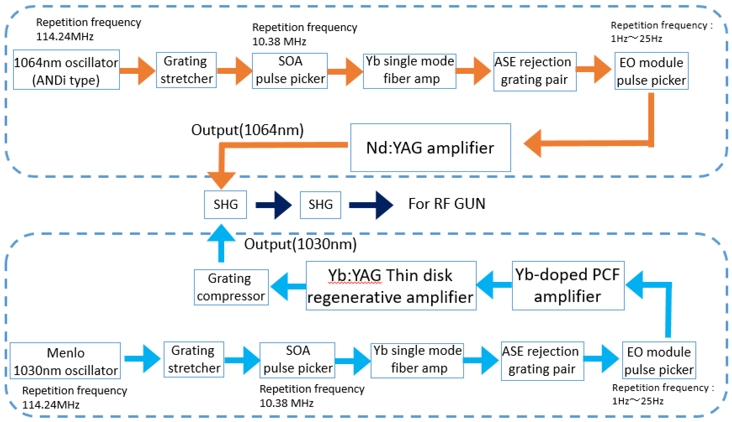
Figure 1: Layout of Laser system
To obtain the mJ-class pulse energy, 1064 nm signal was send to an Nd:YAG amplification system. After the amplification, the UV pulse was generated by 2 second harmonic generation (SHG) stages. This laser source was developed for the Phase II commissioning in this year.
On the other hand, 1030 nm signal was send to a Yb-doped fiber polarizing double-clad photonic crystal fiber (PCF) amplifier and Yb:YAG thin-disk amplifier with the CPA system. This laser source was developed for the Phase III commissioning in next year.

Fiber Part for 1030nm and 1064nm
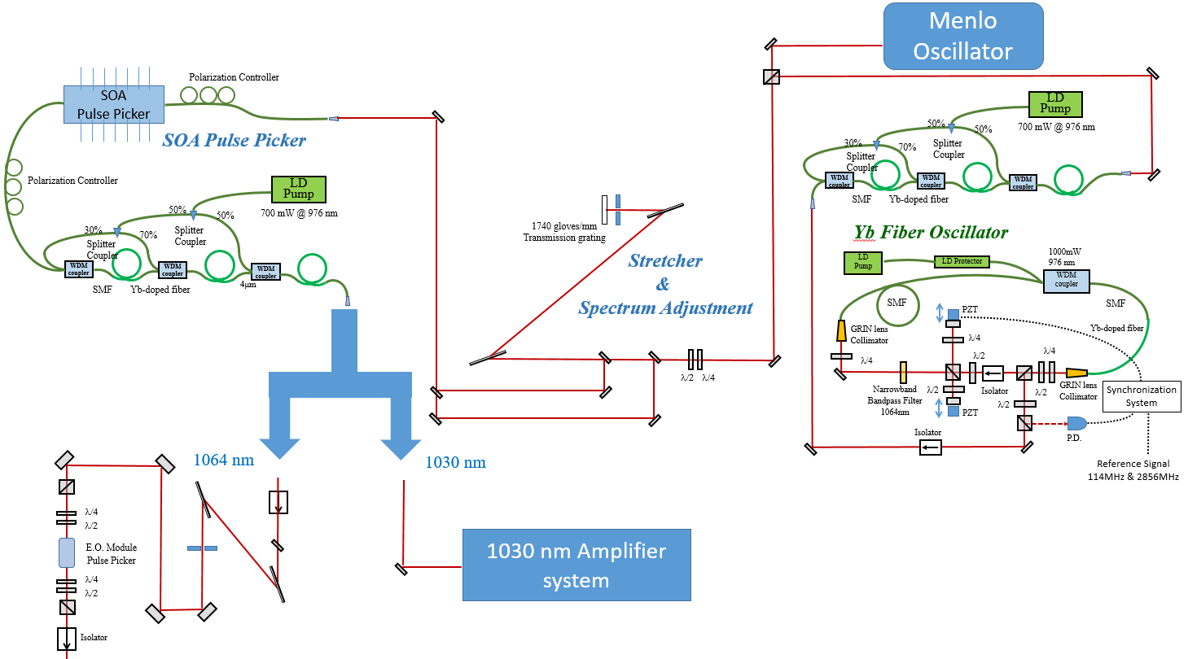
Figure 2: Fiber part structure
A stable 114.24 MHz (10.38*11 MHz) Yb-doped fiber ANDi type oscillators was developed. The center wavelength was chosen by a bandpass filter in the cavity. Here, the oscillator was employed to generate the seed pulses at center wavelength of 1064 nm. And a commercial fiber oscillator that produce was also import. The spectral range is cover from 1025 to 1050 nm. This commercial oscillator was used for 1030 nm laser amplifier.
For the low power amplification, single-mode Yb-doped fiber with the core diameter 4 μm was coupled with the 976 nm laser diode (LD) pump by a wavelength-division multiplexing (WDM) coupler same as the oscillator. Because the amplified spontaneous emission (ASE) easy to be amplified with the weak seed pulse by strong pump power, the 700mW pump LD was separated to 3 parts with the pump power of the 15%, 35%, and 50%, respectively. All the 3 amplifiers were coupled each other with no free space.
1740 grooves/mm transmission grating pair stretcher was employed to expend pulse to ~20 ps and reshape the center of the spectrum shaping at 1064 nm (0.3 nm bandwidth), which fit for the gain area of the Nd:YAG crystal.
The SOA pulse picker inside after the stretcher to reduce the repetition rate from 114 MHz down to 10.38 MHz. The pulse picker was driven by a ~5 ns 100 mV electrical pulse at 10.38 MHz amplified through a high power RF amplifier. Another 3 steps Yb-doped fiber amplifier was employed to compensate the energy lose.
For 1064 nm amplification, the ASE noise of 1030 nm added to the signal during the SOA amplification. Therefore an additional transmission grating was used to separate and cut the noise by a slit.
After fiber amplifier, an Electro-optic module (E.O.) worked as a pulse picker is used to pick out the 1-25 Hz signal from a sequence of pulses of 10.38 MHz. The E.O. was synchronized to the pulse repetition frequency of 10.38 MHz, with the signal to noise ratio of more than 100.
The detail of fiber part that shows in fig.2 was described at ref [1].

Nd:YAG Part with Regenerative Amplifier
Diode pumped solid state (DPSS) Nd:YAG laser is solid state lasers made by pumping a solid Nd:YAG gain medium with a laser diode. The main advantages of diode lasers are overall laser efficiency and extended pump-source lifetime. 808 nm pump light was generated by the diode pump module with the pulse width of 200μs at 25 Hz. The Nd:YAG rod crystal of 1.1% dope-rate was used with the AR coating at 1064 nm by both surface.
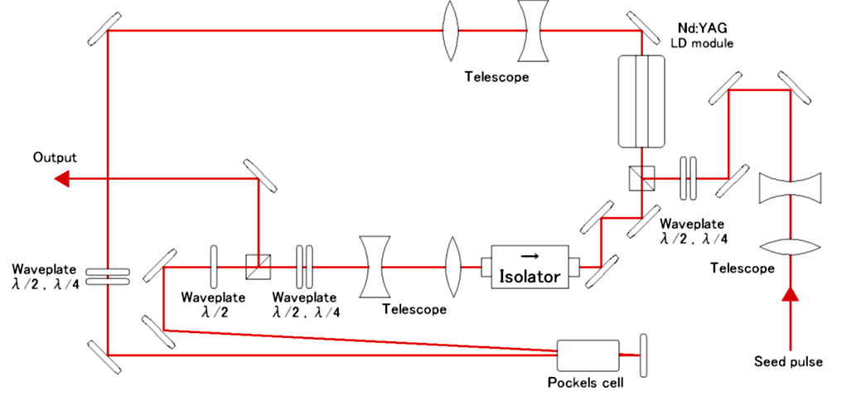
Figure 3: Nd:YAG Rod regenerative amplifier
For low-energy nJ pulse amplification, regenerative amplifier system with large number of round trips is a good selection for compact the laser structures. Firstly a regenerative amplifier was employed, consists of a ring cavity having a Nd:YAG rod crystal. Consider the response speed of the pockels cell (~20 ns), the total cavity length of the one round trip is about 7 m (Fig. 3). The crystal size is 2×79 mm, with 2-3 amplification factor by one round-trip. The pulse energy of 2.0 mJ was obtained.
After regenerative amplifier, a 2-pass amplifier was used by a 4×93 mm size Nd:YAG crystal. UV pulses were generated by using two frequency-doubling stages with 5 mm thickness beta barium borate (BBO) crystal. More than 400 μJ UV pulses was generated to RF gun.
The temperature of the laser room (measured at the base of the regenerative amplifier) had a significant effect on the system performance, as shown in Fig. 4. The regenerative amplifier (green curve) and 2-pass amplifier (blue curve) maximum output pulse energy decreased by 90% while the room temperature range (pink curve) change of 0.3 °C. By contrast, the fiber output power (red curve) was stable.
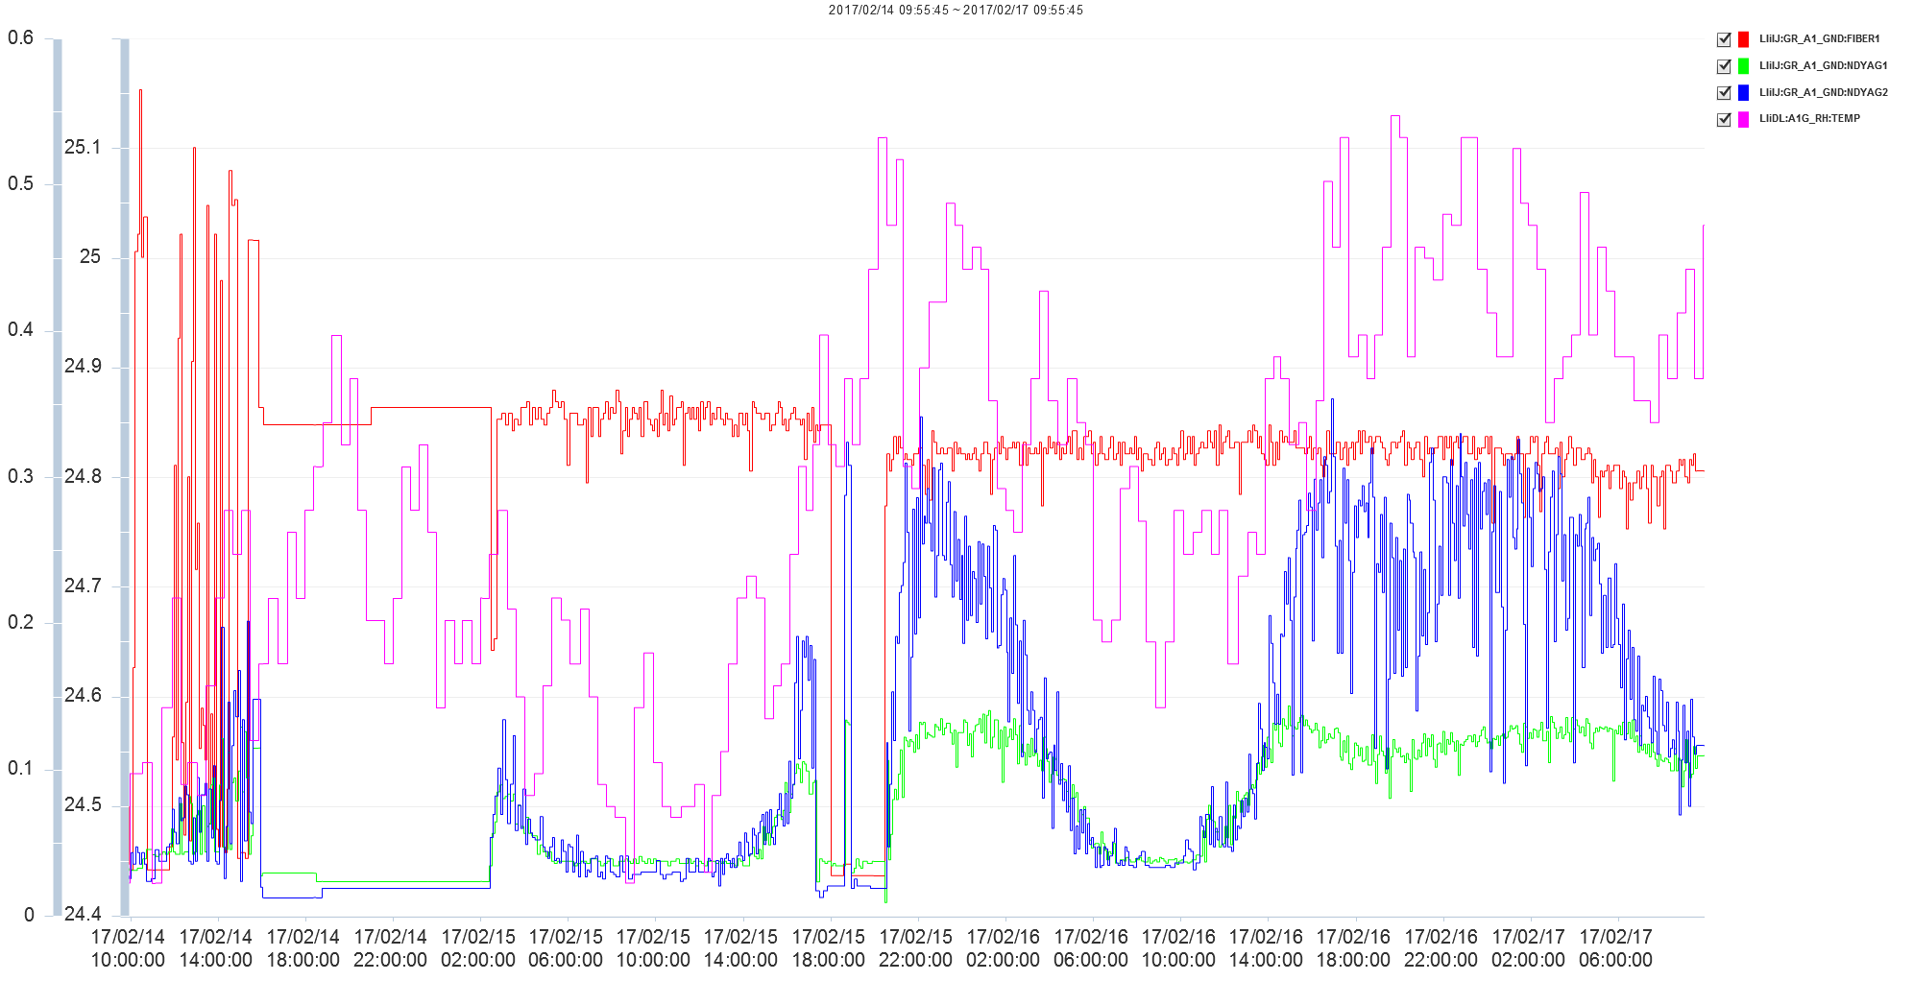
Figure 4: Output log date for regenerative amplifier
Although, a compact efficient regenerative amplifier system was constructed, the stability was an issue for application. Then, we developed multi-pass amplifier instead of the regenerative amplifier to increase the pulse energy after fiber amplifier.

Nd:YAG Part with Multi-pass Amplifiers

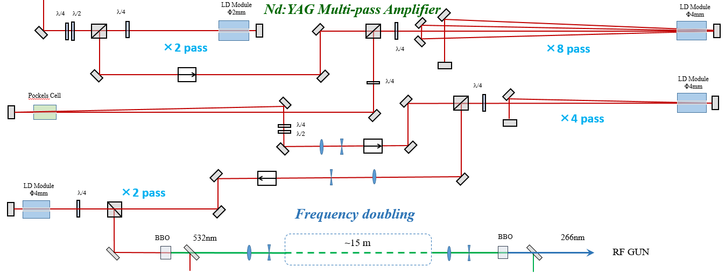
Figure 5: Nd:YAG Rod multi-pass amplifier
The Multi-pass amplifier is simple and stable than the regenerative amplifier, because of no cavity structure. Since multi-pass amplifier work well when only few passes are required, several stages are needed for high energy amplification.
As the fig. 5, the amplified pulses from fiber amplifier first pass through a 2-pass high-gain amplifier with 2×79 mm size Nd:YAG crystal. The beam is then reflected off the Faraday isolator and sent to a 8-pass low-gain amplifier with 4×93 mm size Nd:YAG crystal. Successive beam paths are closer to the optical axis so that the passes has the maximum overlap in the gain crystal to maximize the gain. The amplification factor of the high-gain and low-gain amplifier are about 50 and 5 respectively. After the two stages multi-pass amplifier, the pulse energy was add to several μJ. Although the amplification has not saturated, the ASE noise was occurred when the pump power was increased.
After the second multi-pass amplifier stage, a Pockels cell is employed to rid of the noise that remained from E.O. pulse picker. Then, the signal pass through a 4-pass low-gain amplifier and 2-pass low-gain final amplifier. Between the 2 stage amplifiers, a telescope lens system was used to adjust the beam size to compensate the thermal lens effect that generated at each amplifiers. The optical isolators were employed between the each Nd:YAG amplifier stages to isolation the feedback. The total output energy of the multi-pass amplifier was 4.5 mJ.
4 mm and 5 mm thickness beta barium borate (BBO) crystal are used to two frequency-doubling stages. For the first SHG stage, the 2.1 mJ green pulse was generated at center wavelength of 532 nm. The conversion efficiency of the first SHG stage was more than 45%, that means low amplitude and phase noise remained in the signal pulses.
Because the transport energy loss of the shorter wavelength is larger than the longer wavelength, the second SHG stage was set up near the RF gun. The distance of laser beam transmits from the new laser room to the RF gun is about 15 m by several reflect mirrors and 2 pair of telescope lens systems. 80% 532 nm pulse energy was remained in the transport line. The conversion efficiency of the second SHG stage was more than 25%, with the UV pulse energy of 510 μm was obtained. The total ω-4ω efficiency was up to 10%.

Laser Property
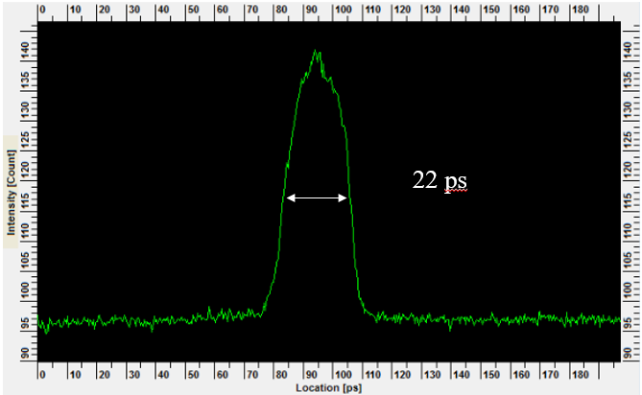
Figure 6: pulse time domain profile
The pulse shape in the time domain was measured by streak camera that shows in Fig 6. The pulse width is near 22 ps, better than the pulse source of the Phase I laser source.
The 266 nm UV laser pulses are injected into the cathode in RF gun with the angle of 60°. For beam commissioning, 1.57+/-0.032 nC beam generation from the gun was achieved with the bunch length of 22 ps in 25 Hz by single or double bunch. The emittance of ε_{Nx}: 22.955+/-0.879, ε_{Ny}: 11.376+/-7.876 was measured.
From experience, the pulse energy of laser source is strong enough for the 2 nC electron beam generation. Fig. 7 shows the beam profile of the 2ω pulses. The profile need be optimized to increase the beam charge.
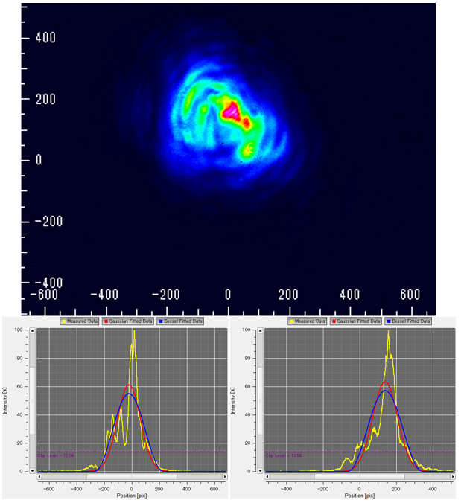
Figure 7: Beam profile of the 2ω
The laser was stable working more than one month without maintenance. Since, some velocity and position drift were occurred at pulse picker and Pockels cell, the re-adjustment should be performed.

In the Furture: Yb:YAG amplifier Part
For the Yb-doped fiber and Yb:YAG thin-disk laser for the Phase I commissioning, the main issuers are nonlinear effect since the high pick energy of the ps pulse, and thermal effect since the bad thermal conduction of the thin-disk cooling system. Firstly, the CPA system should be performed, that stretched pulse width to ns level. Secondly, the cooling condition of the Yb:YAG thin-disk crystal should be improved with the new soldering technology and vacuum chamber [2].

Conculution
For SuperKEKB project, to obtain the 20 ps, 25 Hz, mJ-class pulse energy, a hybrid solid laser is developed. After an Yb-doped fiber oscillator and fiber amplifier, the 1064 nm and 1030 nm signal pulses inject into an Nd:YAG amplifier system and Yb:YAG amplifier system. 4 stages of Nd:YAG rod multi-pass solid-state amplifier were employed to instead of the Nd:YAG rod regenerative solid-state amplifier. 22 ps, 510 μJ UV pulses source was generated by laser system. The laser source shows the good beam quality and stability for Phase II commissioning.

References
[1] X. Zhou, et al., “Neodymium and Ytterbium hybrid solid laser of RF gun for SuperKEKB”, THPMY041, IPAC’16, Busan, Korea, (2016).
[2] R. Zhang, et al., “New Achievements of the Laser System for RF-Gun at SuperKEKB Injector”, TUBAB056, IPAC17, Copenhagen, Denmark, proceedings of this conference.

